**The 7 Real world steps to a fully functional website:**

1. **Define your project**

* Define the goal of your project: seeling e-books, building a blog etc
* Define your audience
* Design with your goal and audience in your mind

1. **Plan Out Everything**

* Plan your content: text, images, videos, icons etc.
* Start thinking about visual hierarchy (Content-first approach, website first approach)
* Define the navigation
* Define the site structure if it’s a bigger project (drawing a sitemap)

1. **Sketch Your Ideas Before you design**

* Get inspired and think about your design.
* Get the ideas out of your head: Sketch your ideas before start designing.
* Make as many sketches as you want, but don’t make it perfect.
* Never start designing without having an idea of what you want to build

1. **Design and Develop your website**

* Design your website using guidelines and tips you have learned in the web design section.
* Do that using HTML and CSS: Designing in the browser (desiging and developing in the same time)
* Using sketches, content and planning decisions you’ve made in steps 1,2 and 3
* This step is the biggest part of building a website, but: all steps are important

1. **Optimization**

* Optimize performance: site speed.
* **SEO –** Search engine optimization

1. **Launch the masterpiece**

* All you need for launching is a webserver that will host your website and deliver it to the world.

1. **Site Maintenance**

* Launching is not the end of the story
* Monitor your user’s behaviour and change your website if necessary
* Update your content regularly

**Folder Structure:**

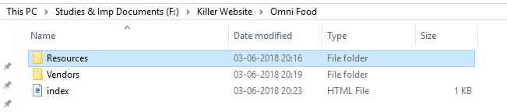

**Resources:**  For own written files

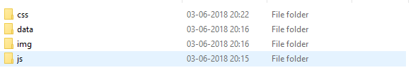

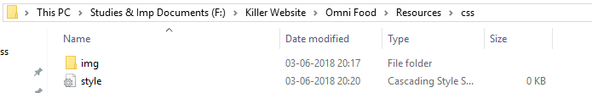

**Vendors:** For built-in JS, CSS files

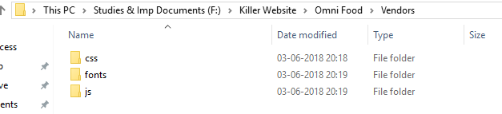

**Normalize.CSS:**

Link: <https://necolas.github.io/normalize.css/>

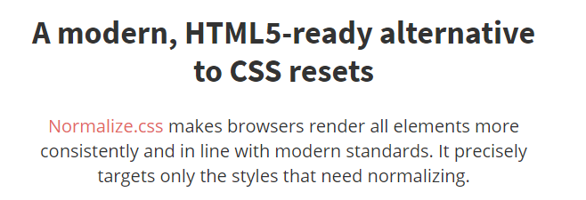

**Google Fonts:** For this website we are using LATO

Link: <https://fonts.google.com/?query=LATO>

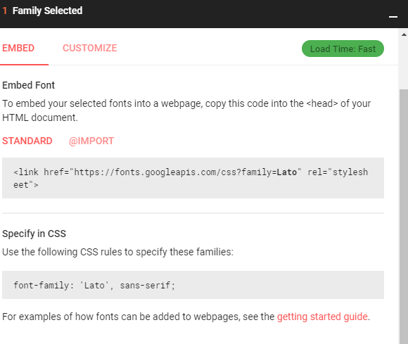

** Always set margin and padding to 0px;

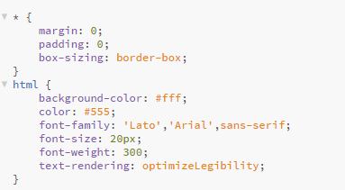

The **text-rendering** CSS property provides information to the rendering engine about what to optimize for when rendering text.

**optimizeLegibility**

The browser emphasizes legibility over rendering speed and geometric precision. This enables kerning and optional ligatures (makes our fonts rendering in a perfect way)

**RESPONSIVE WEB DESIGN:**

* Building responsive web design means that, that website work well on any device will work with any resolution.
* Working well means that easy to read and to navigate without needing to constantly zoom in and zoom out.

**Three ingredients for building Responsive websites:**

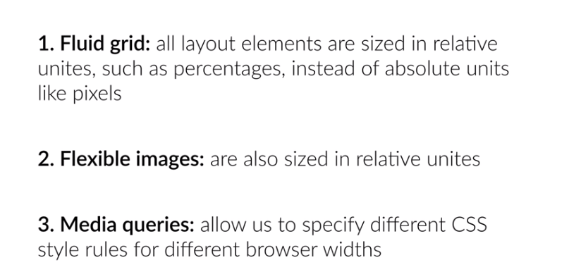

Link: <http://www.responsivegridsystem.com/> (Example fluid grid)

**Header Section of OMNI FOOD:**

Layout:

